LAB ASSIGNMENT AB23.2

Knight's Tour 1

Background:

The Swiss mathematician Leonhard Euler (1707 – 1783) proposed a problem regarding the movement of the knight chess piece on a chess board. The challenge that Euler proposed was to move the knight around an empty chessboard, and to touch each of the 64 squares once and only once.

Directions: To start, move the knight from any position on the board using its standard L-shaped moves (two over in one direction, then one in a perpendicular direction). Practice on this empty grid. Number any position as 1 and then visit as many squares as possible, numbering each move as you go:

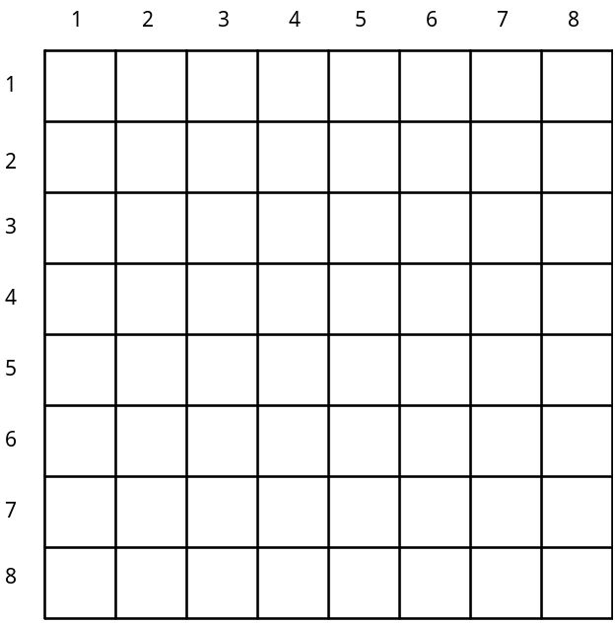

This task is much more difficult than it first appears!

Assignment:

Your task in this lab is to write a program that will move a knight around an empty chess board, leaving behind a trail of increasing integers, ranging from 1 to, hopefully, 64. Here are the specifications for your assignment:

1. The knight will start in row 1, column 1.

2. The program will mark squares as they are visited, ranging from 1-64.

3. The program will continue until a complete tour is accomplished (all 64 squares) or the program gets stuck with nowhere to go.

4. The program will print the results, looking something like this:

1 2 3 4 5 6 7 8

1 1 0 21 0 0 14 23 12
2 20 0 6 9 22 11 0 0
3 7 2 19 36 15 46 13 24
4 0 5 8 47 10 37 0 45
5 0 18 3 16 35 44 25 38
6 4 31 34 0 42 39 28 0
7 0 0 17 32 29 26 43 40
8 0 33 30 0 0 41 0 27

47 squares were visited

5. Use Math.Random() to generate the necessary random numbers.

6. Here are two suggestions to solve this lab.

Suggestion 1: Think about the 8 different possible moves a knight can make from a square. If we analyze them, we can break each one down into a horizontal and vertical component.

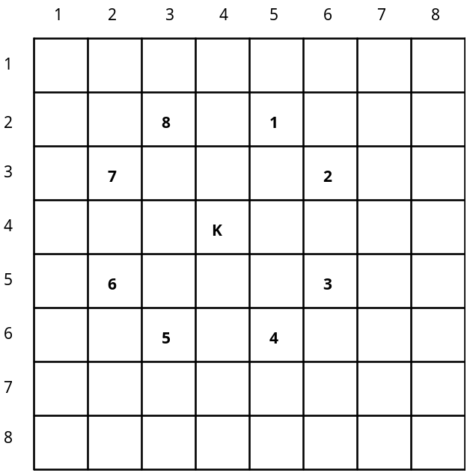

Here are the 8 different possible moves analyzed as horizontal and vertical components:

Move | 1 | 2 | 3 | 4 | 5 | 6 | 7 | 8
horizontal | +1 | +2 | +2 | +1 | -1 | -2 | -2 | -1
vertical | -2 | -1 | +1 | +2 | +2 | +1 | -1 | -2

If you stored the above data in 2 arrays, called horizontal and vertical, it would be possible to move the knight to the next square using a statement like:

row = row + vertical[moveNumber];
col = col + horizontal[moveNumber];

This kind of approach will help to simplify your program.
(note: it might be even MORE helpful to have these as ArrayLists)

Suggestion 2: Declare the board as a 9 x 9 grid.
This will allow you to work with rows 1..8 and column 1..8. Row 0 and column 0 will not be used in this approach.

